EXPERIMENT - 5
IPTables Firewall Configuration in Kali Linux
Aim:
To perform and analyze various firewall configurations using IPTables in Kali Linux to control network traffic and enhance system security.

Procedure:
Step 1: Start Environment
Open Oracle VirtualBox and start Kali Linux virtual machine. Log in to the system.
Step 2: Open Terminal and Check IPTables
Open the terminal and verify that IPTables is installed and available in the system.
Step 3: View Existing Rules
Check the current firewall rules to understand the default configuration before making changes.
Step 4: Configure Firewall Rules
Set default policies to control incoming and outgoing traffic.
Allow necessary services such as localhost communication, SSH, HTTP, and HTTPS.
Block unwanted or suspicious IP addresses.
Step 5: Save and Verify Rules
Save the configured firewall rules and verify that they are applied correctly by reviewing the rule list.

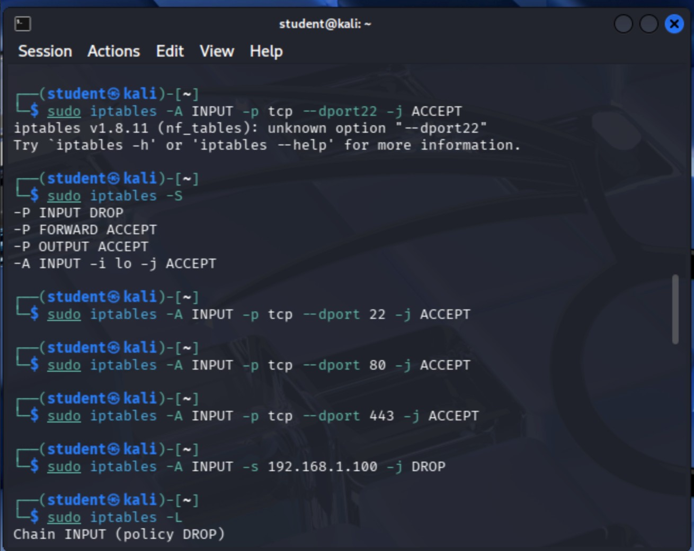

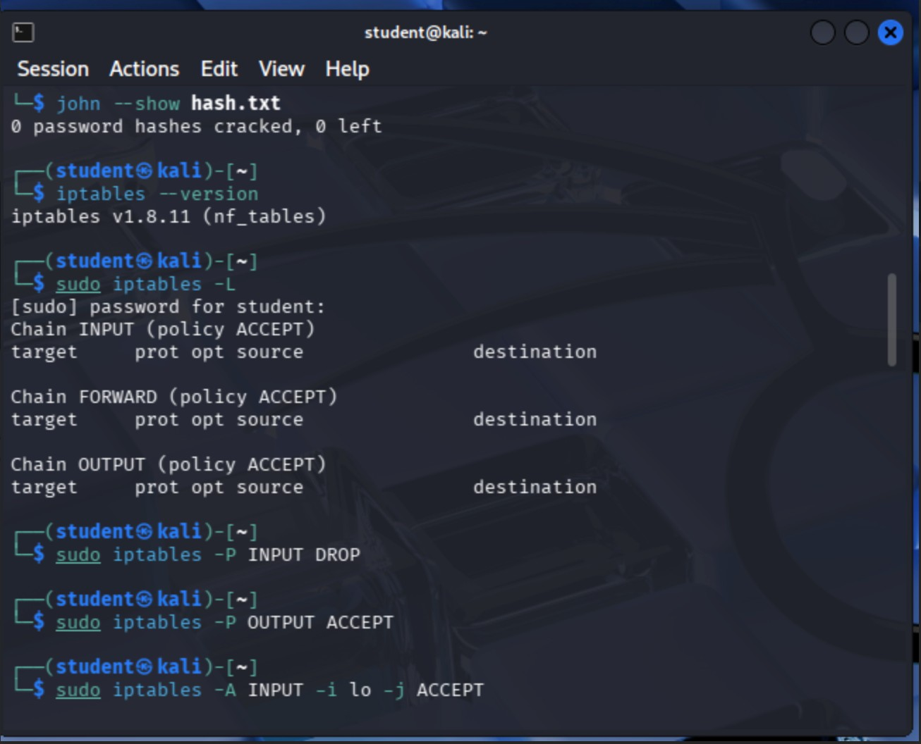
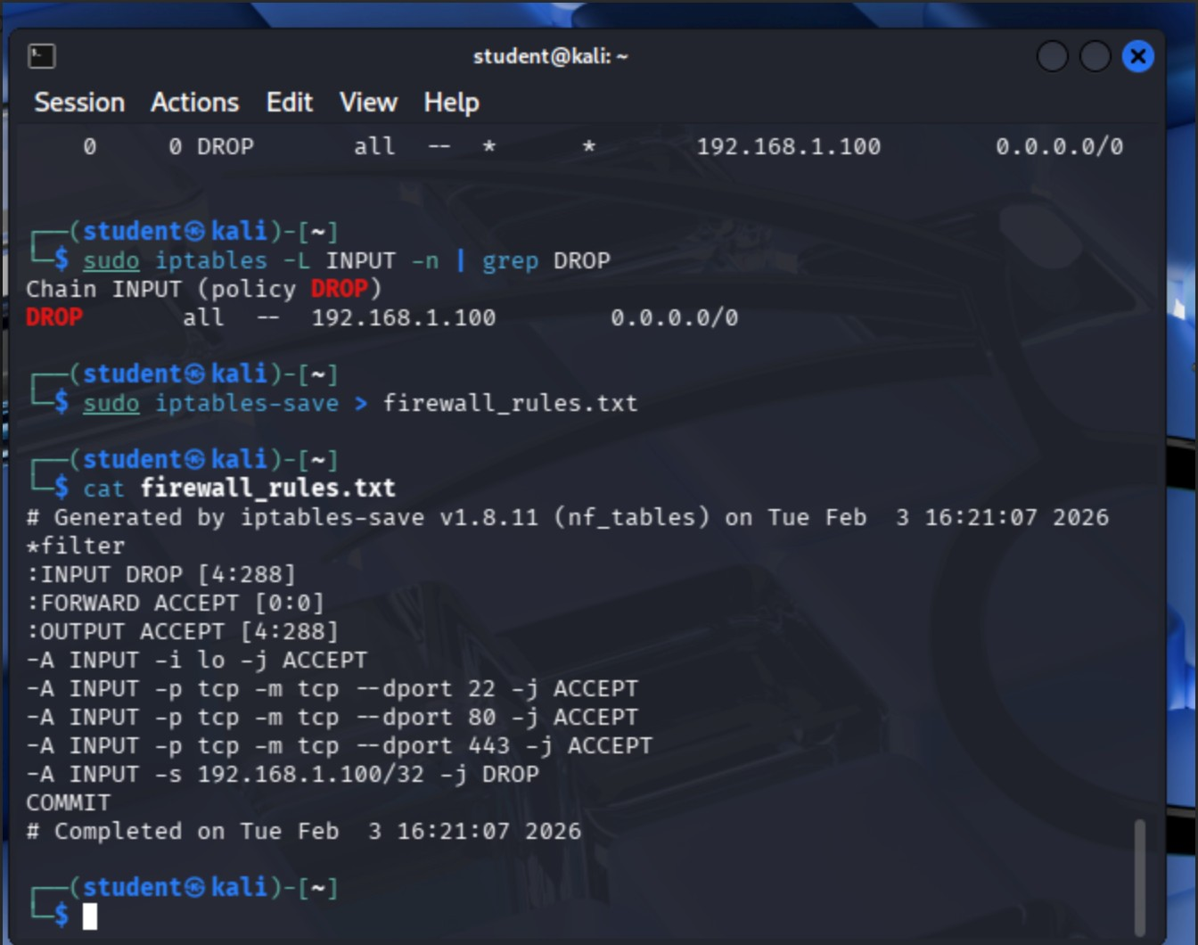

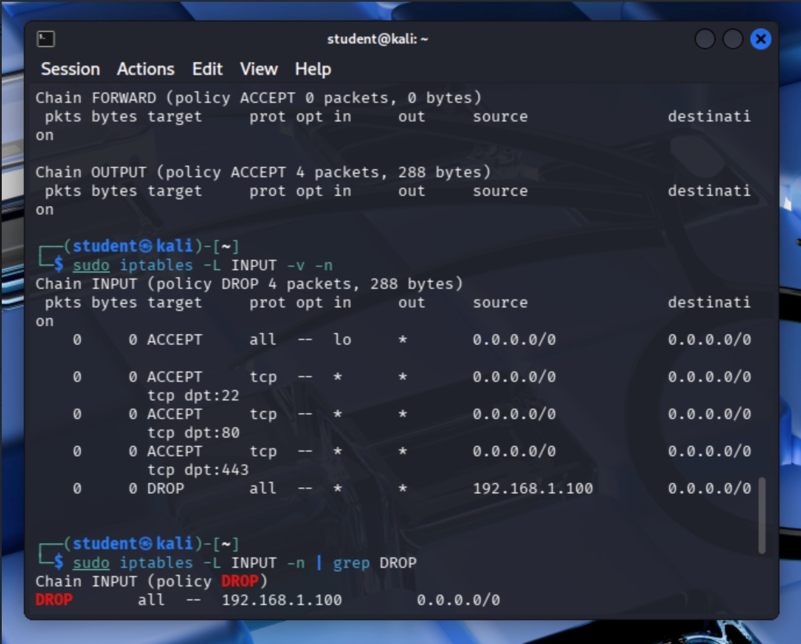

Result
Various firewall rules were implemented using IPTables, demonstrating how network traffic can be controlled to enhance system security.

